Part B: Database Design
David Norton 3616902
Tye Shutty 3605045
CS3103 Rick Wightman
March 14, 2021

Project idea 1
Some user stories to help guide this assignment: 1
ERD 2
Dictionary of stored procedures (names only) and their functionality: 2
Create 3
Read 3
Update 3
Delete 3

Project idea
A personal online audio storage/streaming service.

Some user stories to help guide this assignment:
- Create personal account
- Create admin account
- Log into account
- Change email
- Create folders
- Change folder name
- Organize folders into folders
- Upload audio files
- Download audio files
- View all uploaded audio files
- Change audio file name
- Organize audio files into groups (folders)
- Delete audio files
- Delete account
- Delete other accounts (admin)
- Delete other users’ data (admin)
- Delete other users’ files (admin)
- View number of times file played
- View number of times file was downloaded/saved
- View upload date of file
- View creation date of folder
- Play and pause audio file in browser with volume control

ERD
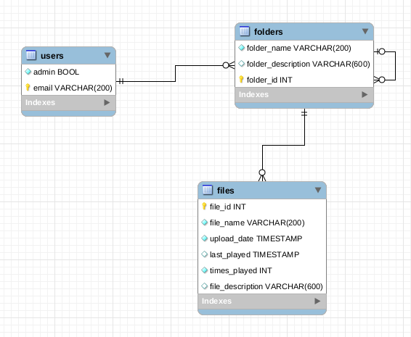
Notes:
- The file_name includes the extension indicating format
- audio files will not be stored in a database, just their metadata
- Each user has a root folder, and the root folder has child folders, and so on.
- The UNB CS system will store username and password used to access many parts of the system

Dictionary of stored procedures (names only) and their functionality:
Please see the sql for full details

Create
- addUser: given email, creates a user for the audio platform
- addFolder: given folder ID, folder name, and folder description, creates a folder with that name under that folder.
- addFile: given file name, file description, folder ID, adds a file with that metadata and a foreign key to that folder. times_played is set to 0 and the current system time is set as upload_date.

Read
- findFolderString : given folder substring and user email, return all matching user folder IDs
- getUser: given user email, returns admin status
- getUsers: returns list of non admin users (admin only access)
- getFolder: given folder ID, returns folder name, parent folder (0 if root) and descriptive text (such as folder genres, number of songs)
- getFile : given file ID, returns file name, parent, upload time, number of plays, last played time and descriptive text (such as genre, length, popularity)
- findFileString : given file substring and user email, return all matching user file IDs

Update
- setFolder : given folder ID and text, replaces description and name
- setFile : given file ID, file description, file name, parent, file last played time, file number of plays, replaces everything except the fileID
- setUser : given old user email, new user email, and admin status, changes user

Delete
- deleteFolder : given folder ID, deletes given folder and all contents, except the root folder
- deleteUser : given user email, deletes user records and all user folders and files, including root folder
- deleteFile : given file ID, the audio file will be removed

